Docker - Introduction to Images, Containers and running first container

Docker - connect to container, logs and network modes

Docker - Writing Dockerfile and Building custom images

Introduction to Docker, understanding images and containers, and running the first Docker container.

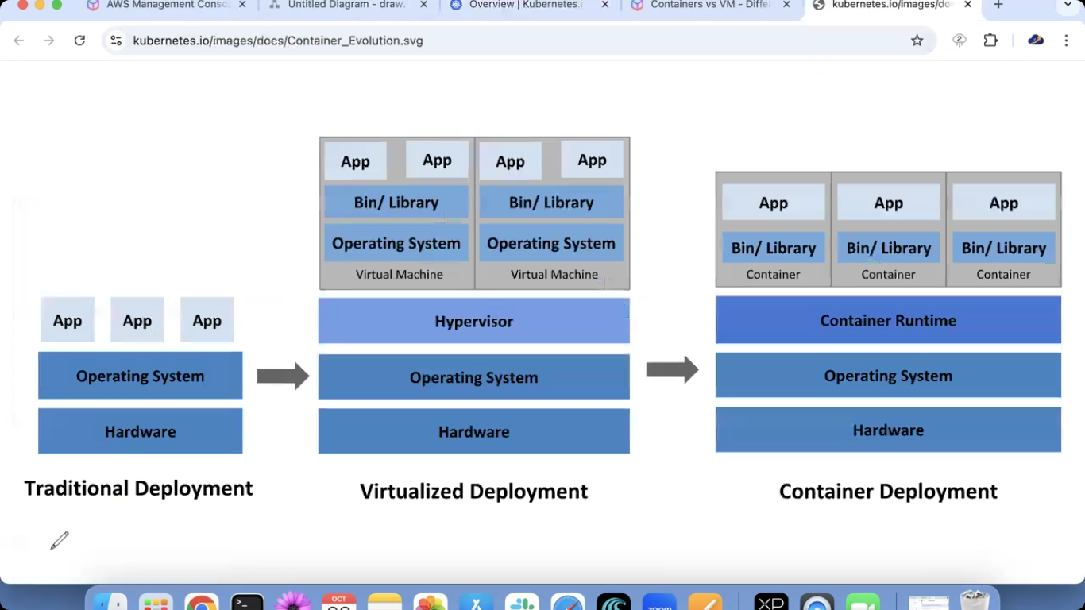

Dnf install docker –y
Systemctl enable docker –now
Systeamctl status docker
Docker –version/docker info
Docker images
docker images --> List all the images we have in this machine.
https://hub.docker.com/
docker ps --> shows running containers
docker ps -a --> shows running and stopped containers

docker run nginx --> Runs nginx image
docker run -d nginx --> Runs nginx image in detached mode

docker run mysql --> if mysql image is not availbale in local, it will pull it from docker hub, then it will run..

images : Nothing but a pre-configured application.. Treat it as an "AMI of EC2 service"..
-----------------------------
[root@ip-172-31-7-243 ~]# docker pull nginx latest
"docker pull" requires exactly 1 argument.
See 'docker pull --help'.
Usage: docker pull [OPTIONS] NAME[:TAG|@DIGEST]
Download an image from a registry
[root@ip-172-31-7-243 ~]# docker pull nginx
Using default tag: latest
latest: Pulling from library/nginx
d7ecded7702a: Pull complete
266626526d42: Pull complete
320b0949be89: Pull complete
d921c57c6a81: Pull complete
9def903993e4: Pull complete
52bc359bcbd7: Pull complete
e2f8e296d9df: Pull complete
Digest: sha256:1beed3ca46acebe9d3fb62e9067f03d05d5bfa97a00f30938a0a3580563272ad
Status: Downloaded newer image for nginx:latest
docker.io/library/nginx:latest
[root@ip-172-31-7-243 ~]# docker images
REPOSITORY TAG IMAGE ID CREATED SIZE
nginx latest d261fd19cb63 27 hours ago 152MB
[root@ip-172-31-7-243 ~]# docker pull httpd
[root@ip-172-31-7-243 ~]# docker images
REPOSITORY TAG IMAGE ID CREATED SIZE
httpd latest 6a4fe18d08d2 27 hours ago 117MB
nginx latest d261fd19cb63 27 hours ago 152MB

docker ps --> shows running containers
[root@ip-172-31-7-243 ~]# docker info
Client:
Version: 25.0.13
Context: default
Debug Mode: false
Plugins:
buildx: Docker Buildx (Docker Inc.)
Version: 0.12.1
Path: /usr/libexec/docker/cli-plugins/docker-buildx

Server:
Containers: 0
Running: 0
Paused: 0
Stopped: 0
Images: 2
[root@ip-172-31-7-243 ~]# docker ps
CONTAINER ID IMAGE COMMAND CREATED STATUS PORTS NAMES
docker ps -a --> shows running and stopped containers
[root@ip-172-31-7-243 ~]# docker ps -a
CONTAINER ID IMAGE COMMAND CREATED STATUS PORTS NAMES
docker run nginx --> Runs nginx image
docker run -d nginx --> Runs nginx image in detached mode
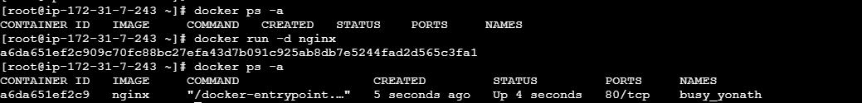

docker run mysql --> if mysql image is not availbale in local, it will pull it from docker hub, then it will run..
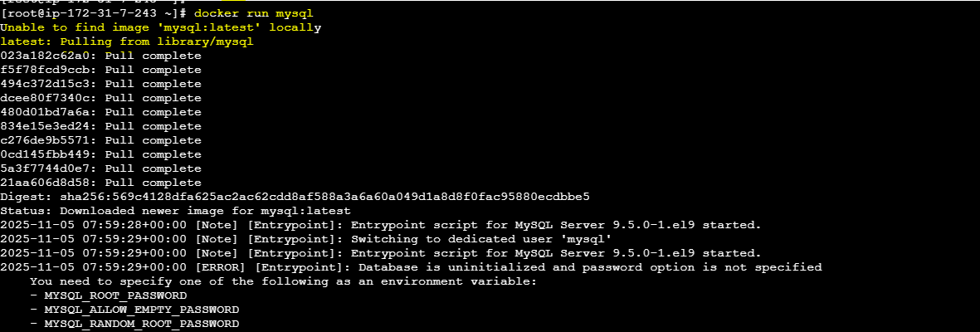

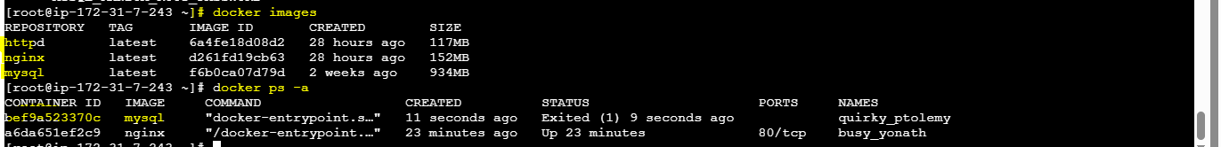

docker rmi mysql
[root@ip-172-31-7-243 ~]# docker rmi mysql
Error response from daemon: conflict: unable to remove repository reference "mysql" (must force) - container bef9a523370c is using its referenced image f6b0ca07d79d
docker rm f6b0ca07d79d
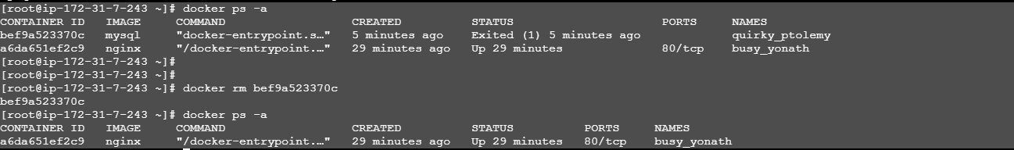
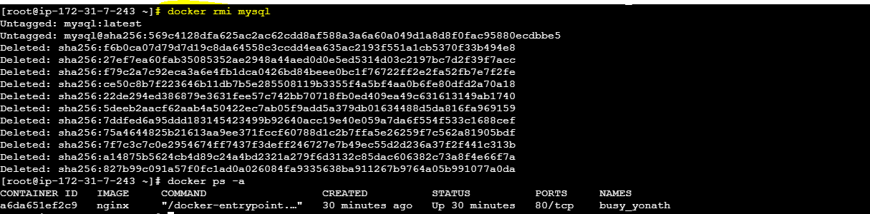

docker stop <container-id> --> To stop the container
docker start <container-id> --> To start the container
docker kill <container-id> --> To kill the container
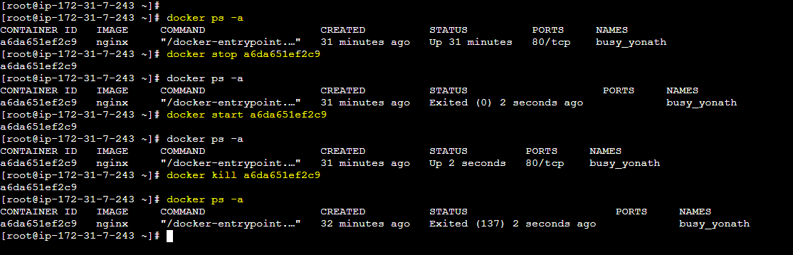

docker run -d -p <host-port>:<container-port> nginx:latest
docker run -d --name mydemo-nginx -p 80:80 nginx:latest
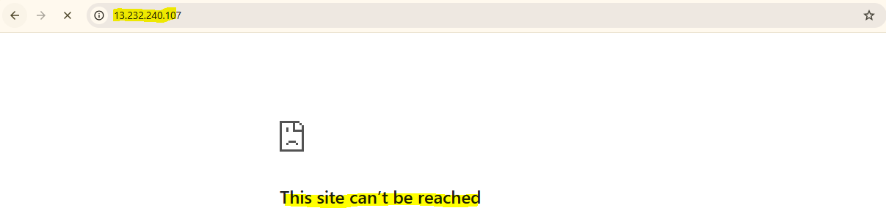

Before stop container
Now start again
docker run –d –p 80:80 nginx:latest
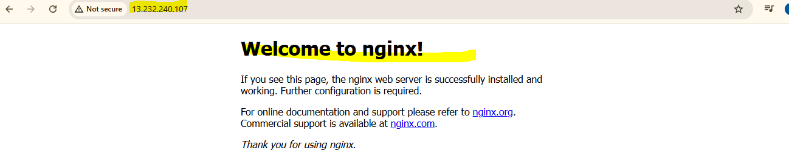

Name changes
docker run -d --name mydemo-nginx -p 8080:80 nginx:latest

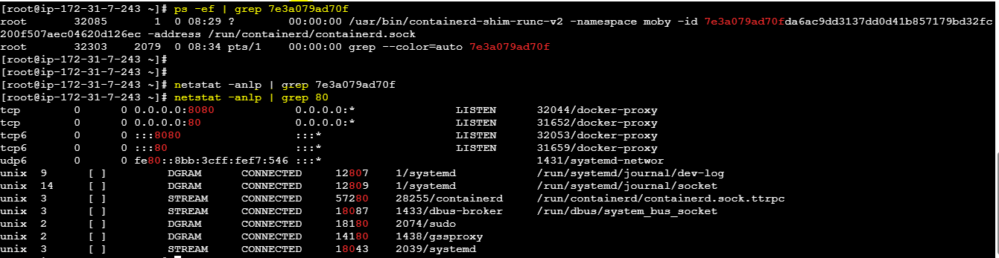

Day 52

Docker - connect to container, logs and network modes
Learned how to connect to Docker containers, view logs, and understand different network modes in Docker.

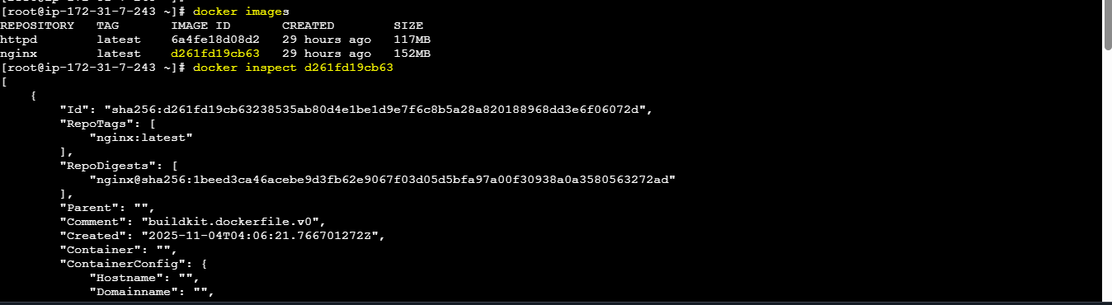

docker exec -it be754c028168 /bin/bash --> TO connect to the running container, we can use this "exec" option.
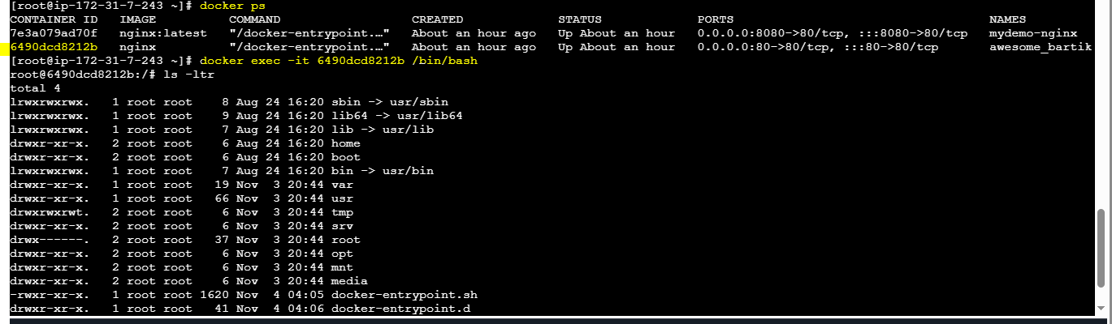

docker logs <container-id> --> To verify the logs of a container

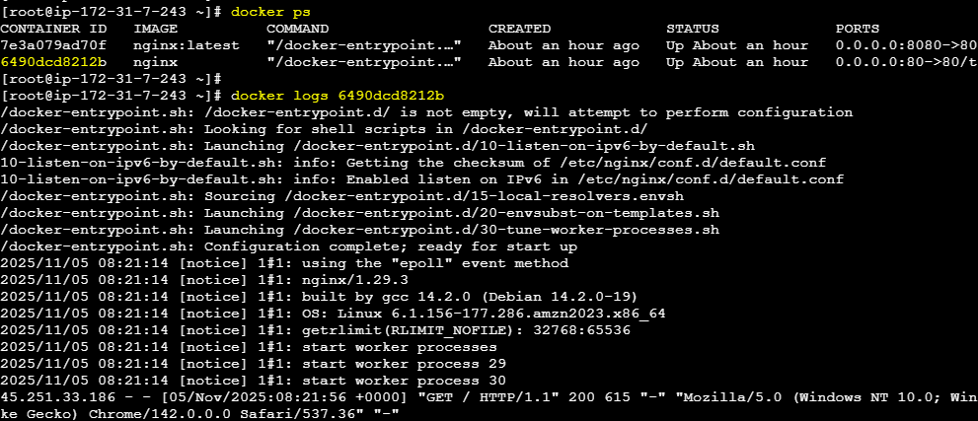
docker top be754c028168 --> Shows running processes inside a container
docker stats --> Shows live CPU, Memory, i/o stats

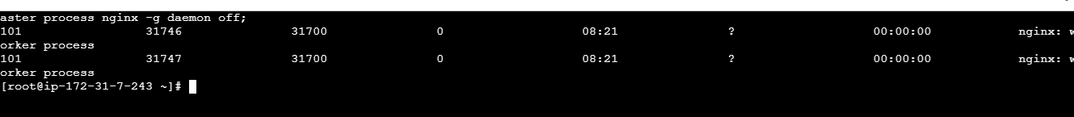

docker run -d -p 80:80 --name myapp --memory=256m --cpus=1 nginx:latest

docker inspect 3a363e2d7c66

docker inspect --format='{{.HostConfig.Memory}}' myapp
docker inspect --format='{{.HostConfig.NanoCpus}}' myapp

docker rename clever_beaver myapp-new
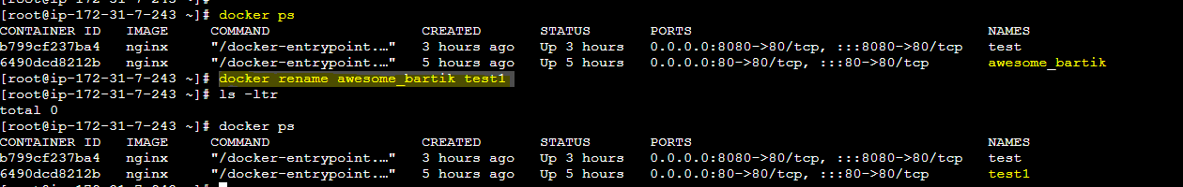
docker cp 3a363e2d7c66:/container.txt ./ --> Copy file from container to local current path
docker cp ./host.txt 3a363e2d7c66:/

[root@ip-172-31-7-243 ~]# docker exec -it 6490dcd8212b /bin/bash
root@6490dcd8212b:/#
echo "this is inside container" > container.txt
ls

Then container to local and local to container copy
root@ip-172-31-7-243 ~]# docker cp 6490dcd8212b:/container.txt ./ (container to local)
echo "local container file" > local.txt
docker cp local.txt 6490dcd8212b:/ (local to container)
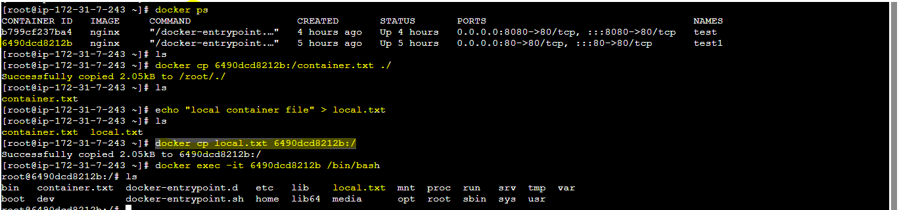

Network Modes in Containers..
Bridge : Default for containers. Internal network where containers can talk to each other..
Host : Container shares the host machine's network.
none : Container has no network at all..
container : Shares network with another container..
overlay : used in docker swarm to connect containers across multiple hosts..
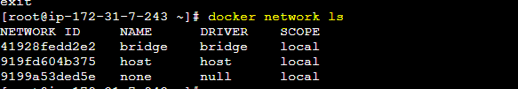

docker network ls --> Shows the network modes we have in current setup

docker network inspect d2fcd90c6672
docker network inspect host
docker network inspect bridge
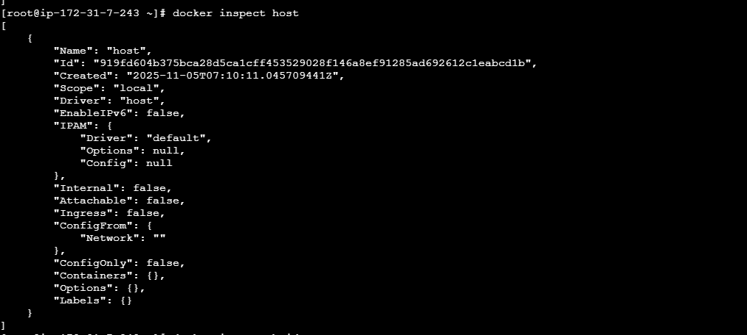
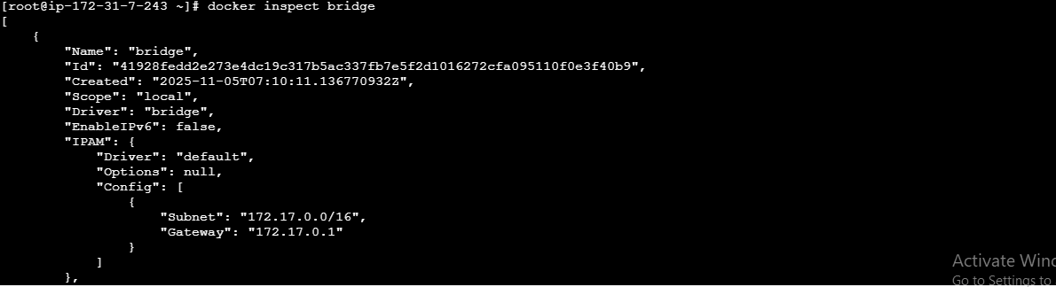

docker network create my_network
docker run -dit --name c1 --network my_network alpine
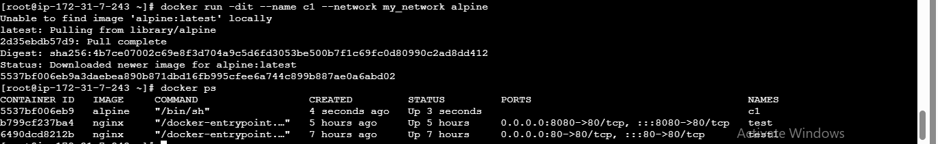

docker run -dit --name c2 --network my_network alpine

Now go to c1 container
Then ping c2 and reaming container aslo
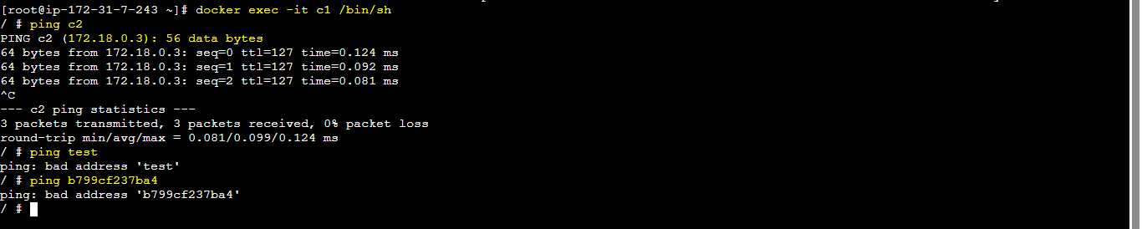

--
docker run -it --network host nginx

Bridge is the common and default network mode we use most of the times.. In AWS, We do have option to run our workload inside a VPC and we always prefer this..

Day 53

Docker - Writing Dockerfile and Building custom images
Learned how to write Dockerfiles and build custom Docker images for application deployment.

Dockerfile : To containerise and deliver our application, we have to first write our own Dockerfiles, then we need to build, need to push it to "Docker Hub" / "ECR (Elastic Container Registry)"..
We can pull it from anywhere and run it..

FROM --> We have to specify the base image to use for building the Docker image. (Base OS)

FROM ubuntu:20.02
FROM alpine:latest

---

RUN --> Executes command in a new layer on top of the above mentioned base image.

RUN apt-get update && apt-get install nginx -y

**We can combine multiple commands into single layer to reduce the image layers and size

---

WORKDIR --> Sets the working directory for the base image.

WORKDIR /app

---

COPY --> Copies files/directories from the local/host to the image we are preapring. Unlike ADD, it doesnt unpack archieves.

COPY /home/ec2-user/mydata/ /usr/share/nginx/html/
COPY . .

---

ADD --> Similar to COPY, but supports archieve extractions.. (.tzr.gz)

ADD my_data.tar.gz /app/

FROM
LABEL OWNER
WORKDIR
COPY ..
RUN PIP
EXPOSE
CMD
FILE NAME
Dockerfile

---

FROM python:3.15.0a1-alpine3.22

LABEL owner="avinash@avinash.com"

WORKDIR /usr/src/app

COPY . .

RUN pip install --no-cache-dir -r requirements.txt

EXPOSE 80

CMD ["python","app.py"]
docker build -t my-python-app:v1
we check python images which one better will cjeck
https://hub.docker.com/_/python
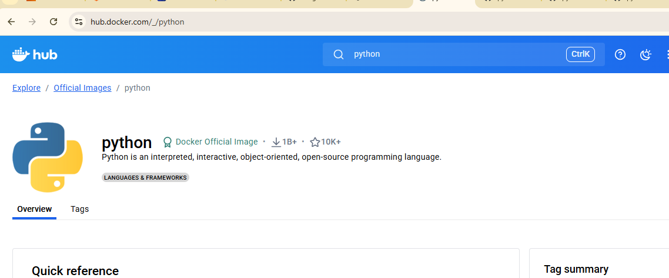

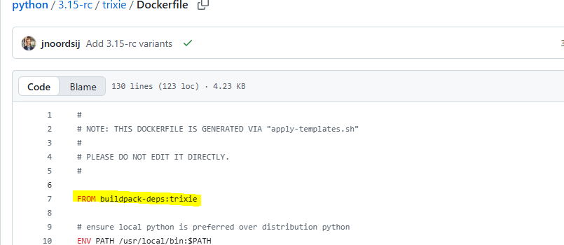

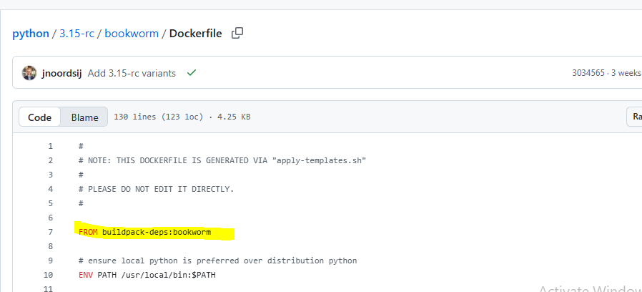
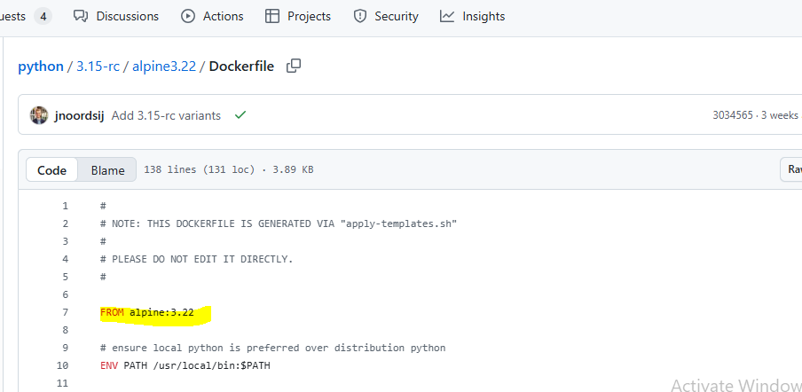

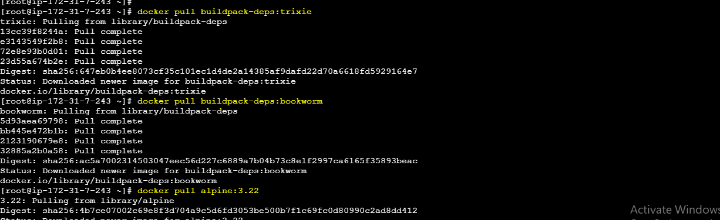

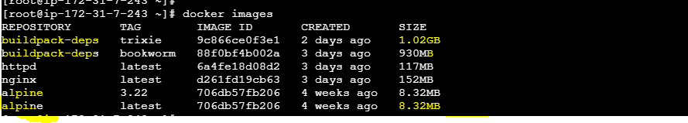
Alpine better
docker rmi buildpack-deps:trixie
docker rmi buildpack-deps:bookworm
docker rmi nginx:latest
docker rmi alpine:3.22
docker rmi alpine:latest

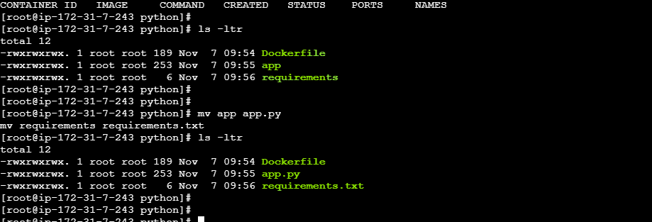

docker run -d -p 80:80 my-first-app:v1

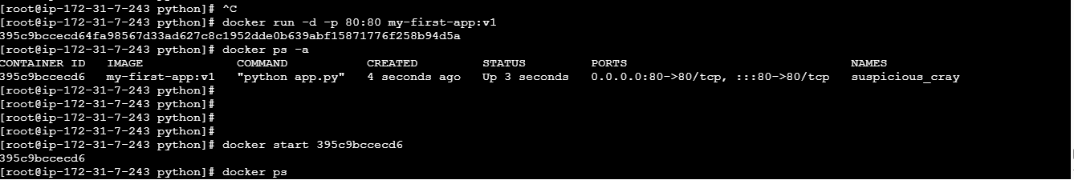

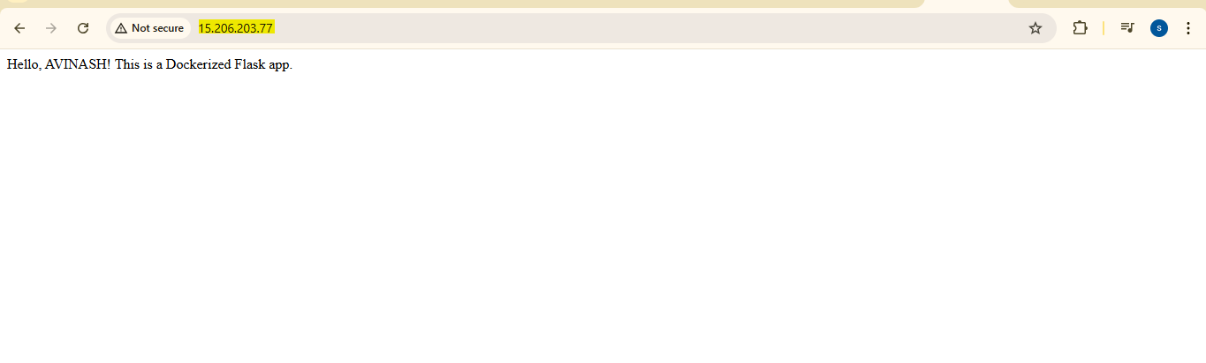

Day 55

Docker - Pushing image to Docker Hub and ECR, Docker Scout for Security
Learned how to push Docker images to Docker Hub and Amazon ECR, and an introduction to Docker Scout for security scanning.

docker build -t <name>:<tag> . --> Docker file should be in same location (Dockerfile)
docker build -t <name>:<tag> ./app --> If Docker file is in diff location (Dockerfile)
docker build -f Dockerfile.dev -t <name>:<tag> ./app --> Build with diff file name
docker build --no-cache -t <name>:<tag> . --> Forcefully rebuild all layers by ignoring the cached layers/data.
docker build --label owner="Avinash" -t <name>:<tag> . --> We can pass metadata
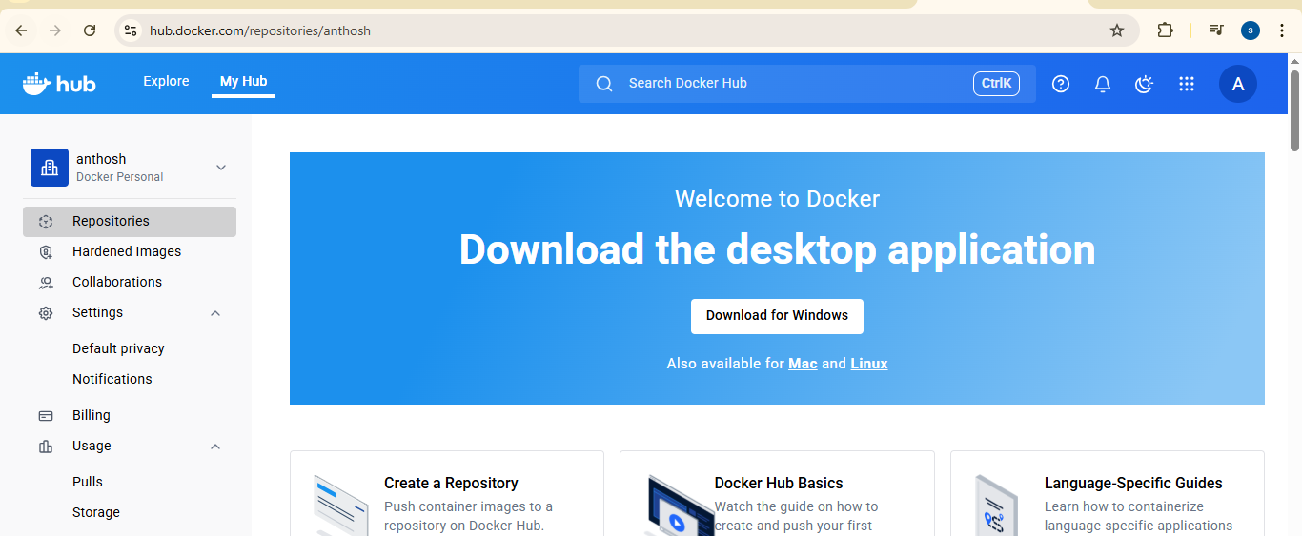

anthosh
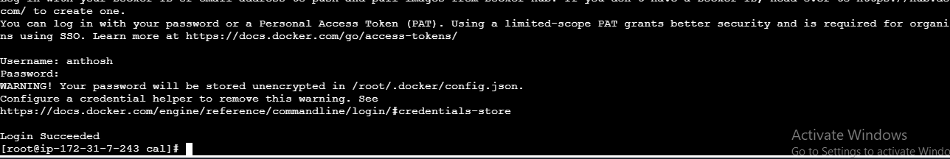

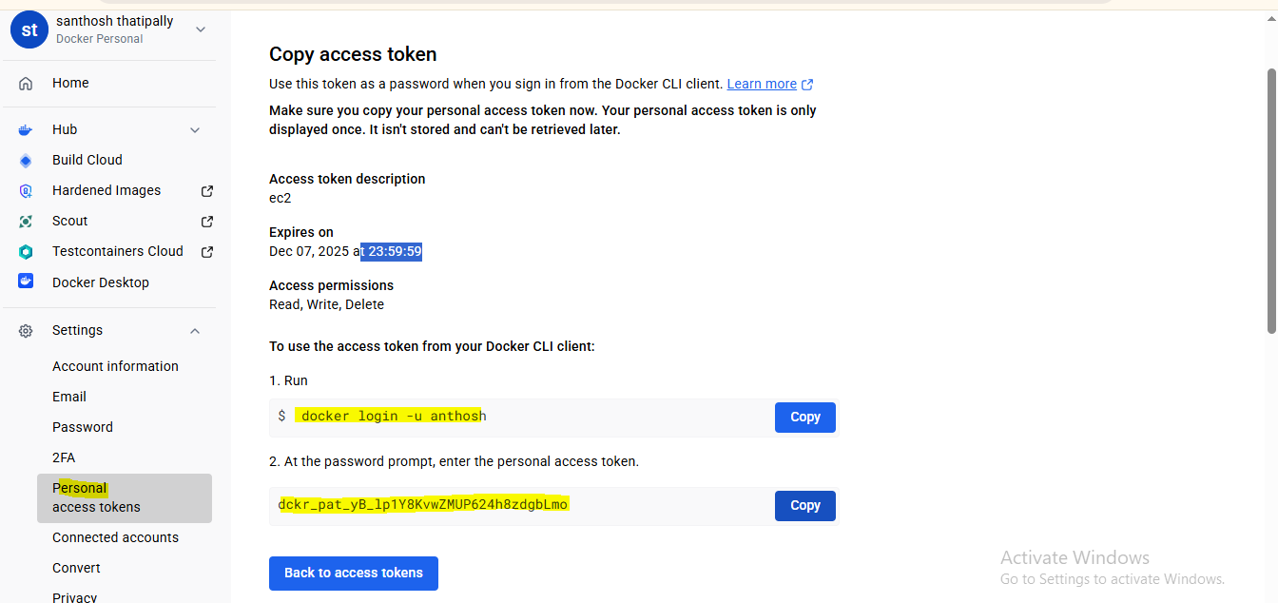

Exit unna images ki tag add afte pull docker
hub.docker.com --> Signup

Your password will be stored unencrypted in /root/.docker/config.json
rm /root/.docker/config.json
dcker tag local-image-name:tag <docker-username>/imagename:tag
docker push thipparthiavinash/mycalapp-awar05:latest

docker tag local-image-name:tag <docker-username>/imagename:tag
docker push thipparthiavinash/mycalapp-awar05:latest

[root@ip-172-31-7-243 cal]# docker images

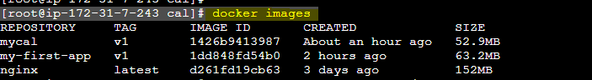

[root@ip-172-31-7-243 cal]# docker tag mycal:v1 aws-05/mycal:v1

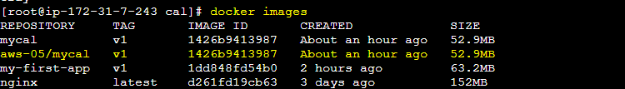

[root@ip-172-31-7-243 cal]# docker tag mycal:v1 anthosh/mycal:v1

[root@ip-172-31-7-243 cal]# docker push anthosh/mycal:v1

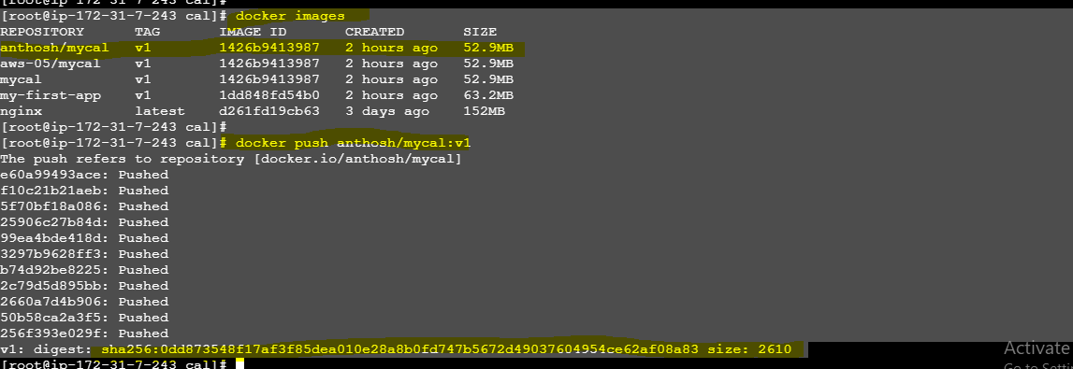
docker pull anthosh/mycal:v1

Without docker
Elastic Container Registry
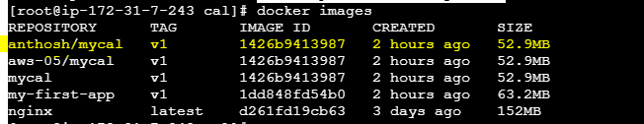

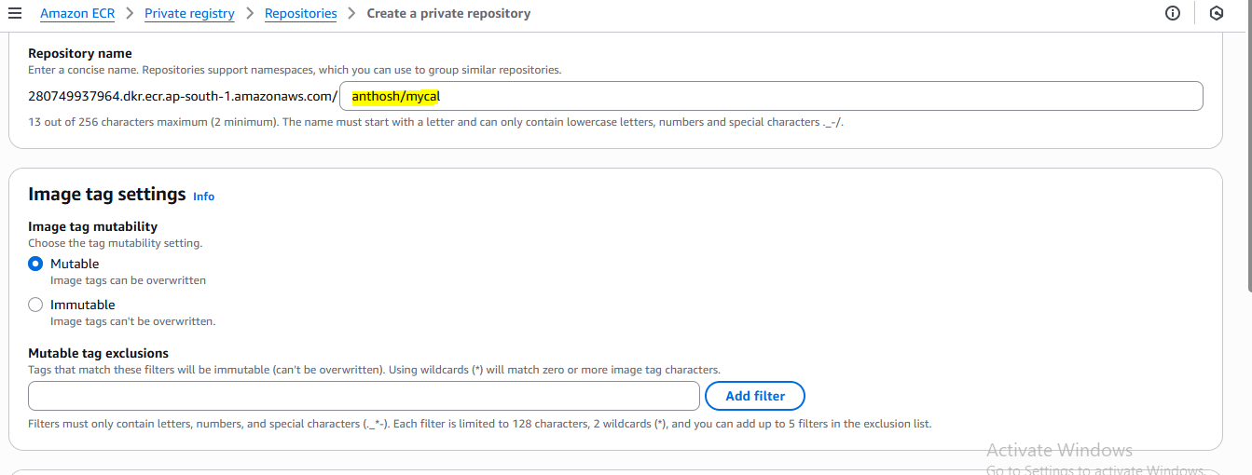

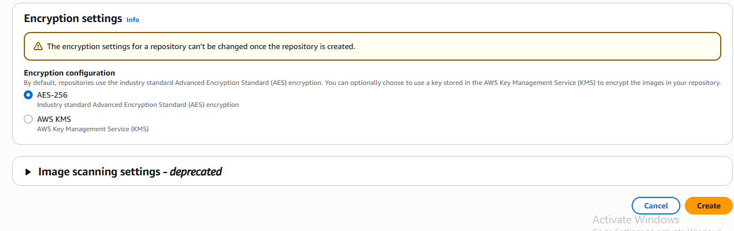

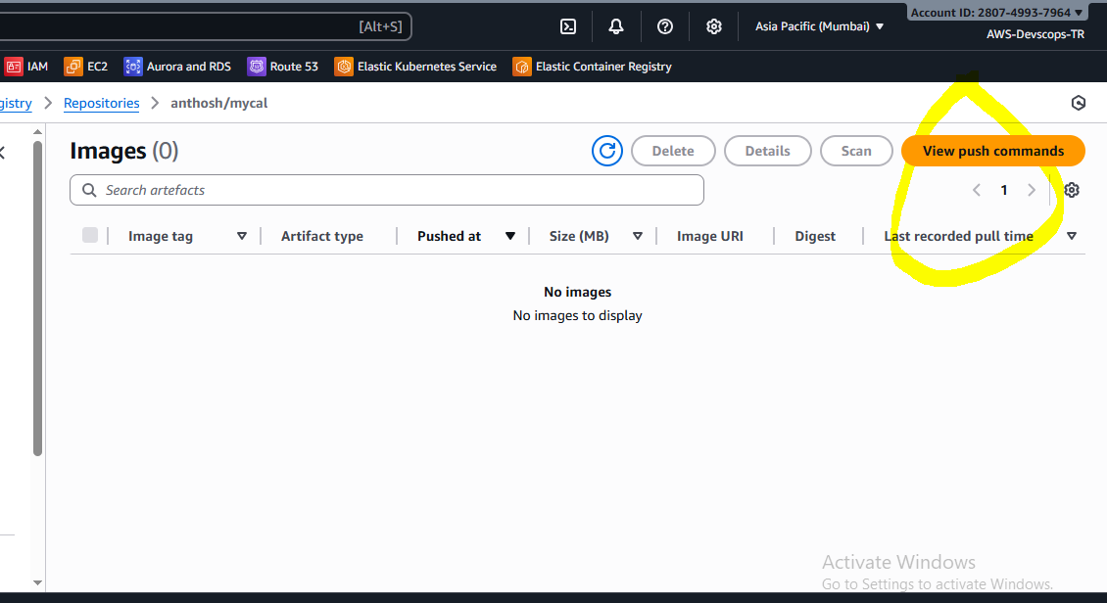

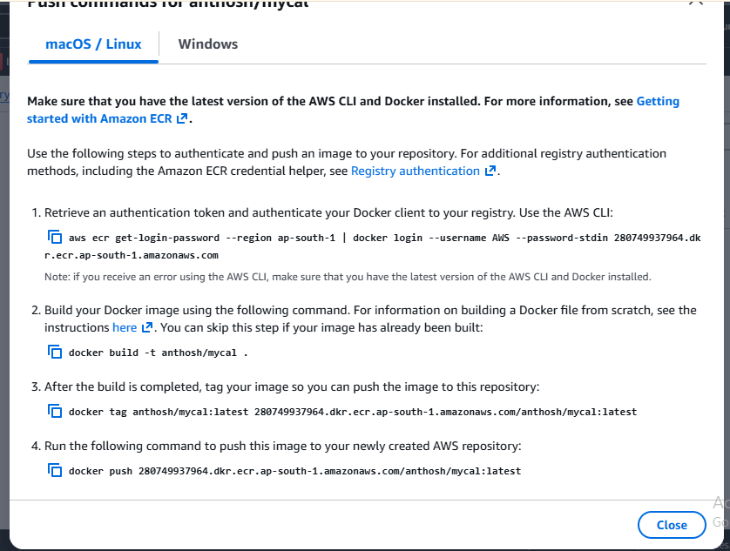

- aws ecr get-login-password --region ap-south-1 | docker login --username AWS --password-stdin 280749937964.dkr.ecr.ap-south-1.amazonaws.com
- docker build -t anthosh/mycal .
- docker tag anthosh/mycal:latest 280749937964.dkr.ecr.ap-south-1.amazonaws.com/anthosh/mycal:latest
- docker push 280749937964.dkr.ecr.ap-south-1.amazonaws.com/anthosh/mycal:latest

Add the IAM rules

